Research Title
Full title: Surface Electromyography Recording of the Upper Limb for Machine Learning-Based Object Grasping Prediction
Short Title: Recording of the Upper Limb for Machine Learning-Based Studies
Ethics Approval Reference No: UAHPEC31659

Executive Summary
This project investigates whether 4 channels of forearm surface electromyography (sEMG) can predict three grasped-object properties: shape, size and grasp. The completed core experiment uses a controlled, seated static-hold task. 15 healthy adults (P01-P15) were recorded on both hands. Each hand was intended to complete 30 object grip conditions, with each condition stored as one approximately 50-second HDF5 recording containing 5 repetitions of 5 seconds rest followed by 5 seconds’ hold. The nominal main-study design therefore contains 900 condition recordings and 4,500 rest/hold repetitions. P03R is the only incomplete participant due to missing data.

Signals were acquired using g.Recorder and a g.USBamp at 1200 Hz, 4 channels, 32-bit floating-point storage and microvolt (mV) units. The primary channel order verified from the main HDF5 files is Extensor Digitorum Communis (EDC), Flexor Carpi Radialis (FCR), Flexor Digitorum Superficialis (FDS) and Flexor Carpi Ulnaris (FCU). The paired electrodes were placed approximately 30-40 mm apart over those muscles, with cables taped and separated to reduce movement artefact and inter-channel coupling. Ground and reference electrodes were placed around the dorsal/lateral and radial wrist regions. The HDF5 signals stored raw signals that do not contain high-pass, low-pass or notch filter.

The dataset supports a strong thesis if its limitations are handled explicitly. Primary evaluation must be participant-independent, keeping both hands and every window from the same participant in the same fold. Shape should be evaluated on a grip-controlled subset, and grip should exclude spheres because sphere trials use only SPH. Size should be evaluated both as six-class classification and as an ordered or continuous millimetre target. P03R coverage, duration outliers, line-frequency interference and unresolved montage terminology must be resolved in a frozen manifest before final modelling.

Research Gaps
A lot of current sEMG studies focus on hand gesture recognition, such as open hand, fist, pinch, or grasp type. They rely heavily on signal amplitude which requires posture and force invariances. However, real applications such as prosthetics, rehabilitation, gaming, or human-machine interaction need more than gesture recognition.

They need to know:
- what object the person is interacting with
  - Size of the object
  - Shape of the object
- What is the grasp mode and is it suitable for gripping the specific object
- whether the system works for a new user (who is not trained)
- whether it still works if the arm/hand posture OR hand placement OR object material OR signal quality changes
- whether the signal changes between different days OR people OR setups

Research Scope

Question:
Can a machine-learning system predict the shape and size of a grasped object and the grasp from four-channel forearm sEMG, and how robust is this prediction to participant, hand, signal-processing and channel-availability variation?

Aim:
Develop and evaluate an interpretable, data-efficient and robustness-aware pipeline that predicts grasp-relevant object properties that includes primarily shape (cuboidal, spherical or cylindrical), size (30, 40, 50, 60, 70, 80mm diameters), and grip type (spherical/SPH, cylindrical/CYL) from four-channel forearm sEMG using leakage-safe participant-independent validation.

Objectives
Stage ONE:
Posture and force-invariant machine learning for grip shape, size and mode prediction (object-property prediction from a supported static hold) using commercial Ag/Cl sEMG electrodes under realistic variation (e.g. new users, posture variances, new sessions, and shifted electrodes). A major issue with sEMG models is that they rely heavily on signal amplitude, which changes drastically depending on how hard a person grips or the angle of their arm.

Breakdown:
- Experiment on 15 to 20 participants with consistent experiment procedure (5 repeated rest/hold cycles per condition), sEMG hardware (wiring, electrode placement, taping, etc) and recorder setup (recording duration, channel configuration, etc), hand and forearm posture, gripping objects’ property (size and shape), and other setups (hand cleaning, participant instructing, etc). Output should be 900 to 1200 raw EMG signal files.
- Create a metadata sheet that records participant information and all other experimental information.
- Establish a reproducible signal processing and segmentation pipeline.
- Benchmark classical machine learning models for shape, size, and grip mode.
- Measure the effect of time-domain, frequency-domain and time-frequency-domain feature sets, including sensitivity to line-noise removal, passband choice, window duration and any other changes.
- Evaluate the model’s robustness to:
  - New unseen participants
  - Left/right dominant arm
  - Channel removal
  - Subject-specific calibration (e.g. global vs. individual normalisation)
- Discuss the result, such as importance of channels and features, uncertainty at participant level, documentation of failure modes, and limitation statements.

Stage TWO:
Develop a software platform that monitors the rehabilitation process by displaying real-time and daily grasping information. Translate data into a readable UI/UX which would visually display the predicted object size/shape/weight and current muscle stability and fatigue levels.

Experimental design
Experiment Overview
Items | Required setting
Participants | 15-20 healthy adults, aged 18 years or older  1 per session, 2 sessions per day  Recruited after consent
Session duration | Approximately 90-120 minutes per session
Primary targets | 2 shapes (cylindrical, cuboidal) * 6 sizes (30, 40, 50, 60, 70, 80mm diameters) * 2 gripping modes (cylindrical/power/CYL, spherical/precision/SPH) + 1 shape (spherical) * 6 sizes (30, 40, 50, 60, 70, 80mm diameters) * 1 gripping mode (spherical/power/SPH) = 30 label conditions (PER HAND)
Core task | Controlled grasp from rest  Rest start (5s) + grip (5s), repeat for 5 times for each object
Postures | Seated, tested forearm relaxed and supported (by sponges and towels) on the table, neutral wrist, palm facing upward/side (up to participants’ comfortableness).  Object placed at optimal gripping position.  Use the consistent postures for all core trials.  Bipolar wires taped together  Wires for different channels are placed distal to each other
Object fabrication | Use standardised 3D-printed objects with matched surface coating and similar friction
Repeat session | If experiment result is invalid or affected, repeat 7-14 days later with electrodes re-applied.
Amplifier | g.tec g.USBamp
G.Recorder settings | Channels: 4 bipolar sEMG channels (Using group B and D)  Global Reference/Ground: Set common ground and reference to group B  Sampling frequency: 1200 Hz  Time interval: 10.0s.  Video: Off (not required for this experiment)  Visualization filters: high-pass >5 Hz, low-pass <500 Hz, notch 48-52 Hz  Adjust until signal is visible but not clipped  Raw data exported
Electrode placement | 4 bipolar channels (placed at centre of EDC, FCR, FDS, and FCU) cantered roughly on the mid-forearm to slightly proximal mid-forearm, avoiding an overly distal wrist-only setup. Use 30-40 mm inter-electrode spacing.
Output format | One raw signal file containing sEMG waveform from all channels in hdF5 format  One metadata spread sheet row per trial

All patient information and setup are recorded in the metadata sheet

Participants
The metadata workbook records 15 completed participants (P01-P15) collected between 22 May and 7 August 2026. Ages range from 21 to 31 years. 10 participants are recorded as male and 5 as female; all are recorded as right-hand dominant; both hands were tested. P16-P20 are placeholders and may not be counted. P00 is the tester/pilot identity.

Preparation and Metadata Recording
Items | Action
Ethics and guidelines | Confirm ethics approval is active.  Prepare Participant Information Sheet, HOD assurance, and this Experimental procedure sheet for participants.  Explain the tasks listed in this experimental procedure document and inform them that the tasks are non-invasive, and they may stop at any time
Consent | Ask participant to sign the consent form
Participant ID | Assign a code before the participant arrives (from P01) instead of using names in signal files
Participant Info | Record all un-identifiable information e.g. age, height, weight, BMI, forearm length, circumference, palm size, etc.
Objects | Prepare all objects  Check labels on each object (shape, size)
EMG setup | Check the connections of the sEMG amplifier, electrode leads, ground/reference lead, USB, and computer. Record the electrode placement in millimetres distance from elbow.
Folders and file names | Folders:  /Data/Bipolar/P0X/P0XL  /Data/Bipolar/P0X/P0XR  /Data/Unipolar  /Data/Pilot Testing  …  Data file naming:  ID(P0X)_Gender(M/F)_Arm(L/R)_ Shape_Size_Posture.hdf5
Timer | Prepare a visible or audible timer
Safety and pilot test | Check cables do not restrict movement  Grasp object in optimal position  Keep wipes and first aid kit available
Pilot test | perform one full mock recording before actual experiment

Electrode Placement and Preparation
Channel | Region | Instruction
CH1 (required) | Forearm extensor (extensor digitorum communis or EDC)  Finger extension and stabilisation; useful counteractivity during grasp. | Place on posterior forearm, along muscle direction, similar distance from elbow/wrist as CH1
CH2 (required) | Radial-side flexor region (Flexor Carpi Radialis or FCR)  Wrist flexion and radial deviation; contributes to wrist stabilisation. | One-third the distance from the medial epicondyle to the radial styloid
CH3 (required) | Forearm flexor (flexor digitorum superficialis or FDS)  Finger flexion, strongly related to object holding. | Place bipolar electrodes along the muscle direction on the anterior forearm, approximately 1/3 of the distance from elbow crease to wrist crease.  Avoid tendons near the wrist.
CH4 (required) | Ulnar-side flexor region (Flexor Carpi Ulnaris or FCU)  Wrist flexion and ulnar deviation; contributes to stabilisation and co-contraction. | One-third of the forearm from the medial prominence
R (required) | Reference | Placed at bony/low-muscle region around dorsal/lateral and radial wrist regions
G (required) | Ground | Placed at bony/low-muscle region around dorsal/lateral and radial wrist regions

Commercial surface electrodes were placed in paired arrangements over each muscle, typically with approximately 30-40 mm displacement. Skin was prepared; placement distances from the elbow were recorded in the metadata. The forearm was supported with towels, and cables were taped both to the arm and along the wire paths. These controls reduce motion artefact and cable interaction but do not prove an absence of physiological crosstalk.
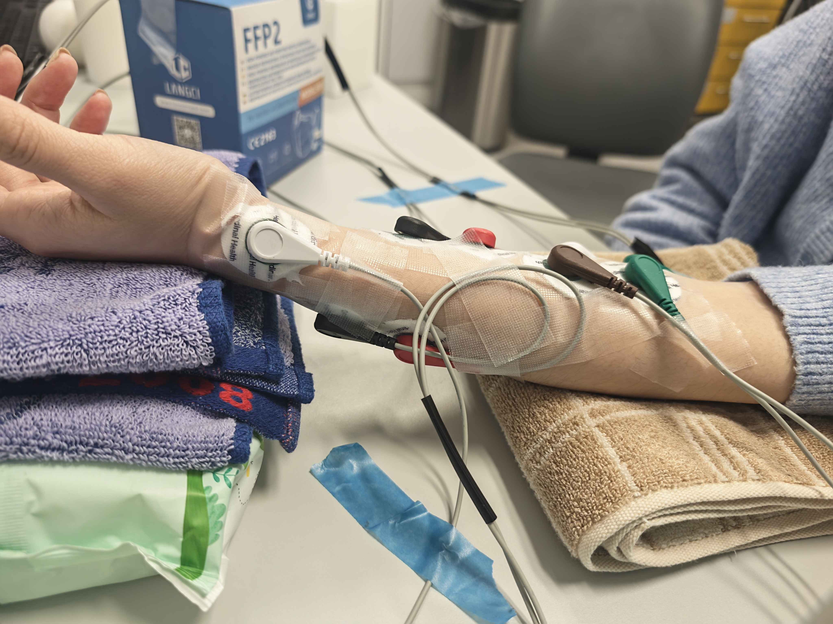

Condition matrix
Shape | Sizes | Grip codes in file name | Conditions per hand
Cuboid | 30, 40, 50, 60, 70, 80 mm | CYL and SPH | 6 × 2 = 12
Cylinder | 30, 40, 50, 60, 70, 80 mm | CYL and SPH | 6 × 2 = 12
Sphere | 30, 40, 50, 60, 70, 80 mm | SPH only | 6 × 1 = 6
Total | Six ordered size levels | Two codes, but not a full factorial design | 30

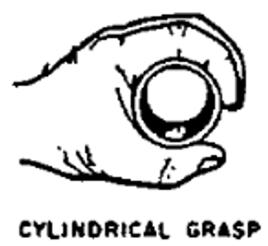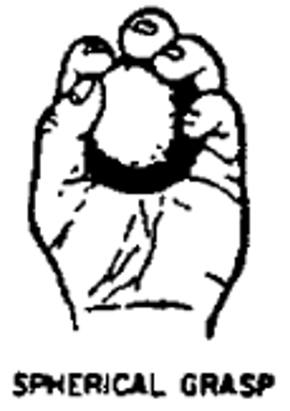

Recording unit and timing
Term | Definition
HDF5 file | Approximately 50 seconds for one participant, hand, shape, size and grip condition.
Cycle/repetition | Nominal 10-second unit: 5 seconds rest followed by 5 seconds static hold (assumed with no transition period).
Repetitions per condition | 5 cycles within one file
Nominal per hand | 30 files, 150 repetitions
Nominal per participant (2 hands) | 60 files, 300 repetitions

Task procedure
Time (s) | Cue | Participant action | Operator action
0 | Start | Put forearm on table (supported by sponges), and put the object at optimal position in open hand (palm facing upward/downward) | Start recording. Watch for baseline noise
0-5 | Rest | Hand open and relaxed, keep forearm flat. | -
5 | Grip | Close hand and grasp object naturally and steadily | Give cue at 5s
5-10 | Hold | Hold object with comfortable, non-maximal force to avoid squeezing | Observe and mark any error
10-15 | Rest (2nd trial) | Release object and return to start position | Give cue at 10s
Repeat x5 | … | … | …
50 | Rest (5th trial) | Release object and return to start position | Stop and save recording

g.USBamp and g.Recorder setup

Component | Verified configuration or role
Amplifier | g.USBamp, a 16-channel, 24-bit biosignal amplifier with four electrically separated channel groups.
Recorder | g.Recorder  HDF5 raw-data recording
Sampling | 1200 samples per selected channel with a two-sample analogue/digital line delay
Selected channels | Four channels. Most files use channels 5, 7, 13 and 15 for EDC, FCR, FDS, FCU, respectively.
Units and array | Samples are float32, N x 4, in microvolts (µV)
Filter | No filter applied to output data

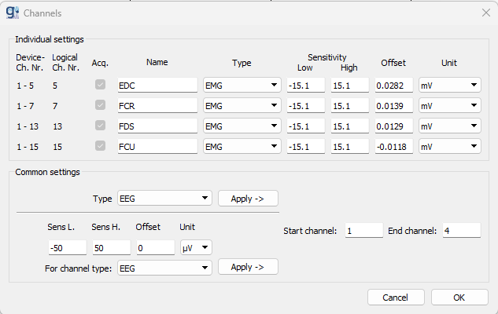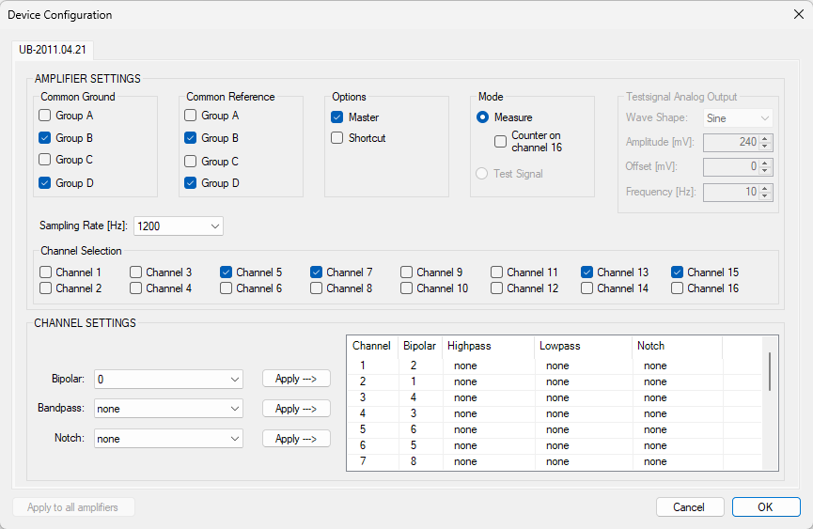

Filename
Example: P03_M_L_cuboid_30_CYL2026.06.18_14.32.10.hdf5
Token | Meaning
P03 | Participant ID
M | Sex
L | Tested hand
cuboid | Shape
30 | Nominal object size in mm
CYL | Grip mode
2026.06.18_14.32.10 | Recorder save timestamp

Signal risks
Risk | Observed evidence | Response
50 Hz interference | Existing audits show very strong 50 Hz and harmonic energy in raw recordings  The lab was known to have substantial mains interference | Quantify PSD before/after Compare notch scope and Q  Use zero-phase offline filtering  Report sensitivity.
Duration variation | Duration of each signal varies in range of 49-51 s, with a median 50.72 s. | Validate cycle count and align. Never assume exactly 60,000 samples.
Potential crosstalk | High inter-channel correlation can arise from common task drive, reference effects, volume conduction or crosstalk. | Use pilot evidence, placement documentation and correlation/lag analyses; do not claim crosstalk from correlation alone.

Stage 1 ML Model Analysis and Endpoints

Question | Design | Primary endpoint
Can grip mode generalise to unseen participants? | CYL vs SPH using cuboid and cylinder only. Sphere excluded | - Accuracy  - Macro-F1  under nested LOSO/grouped CV
Can object shape be inferred independently of grip shortcut? | Cuboid vs. cylinder vs. sphere using power trials only as the primary controlled comparison | - Accuracy  - Pacro-F1  - Confusion matrix  - Participant CIs
Can size be inferred across people? | 6-class size across the defined condition set; also, ordinal/regression in mm. | - Macro-F1  - Accuracy + MAE/RMSE  - Adjacent-error analysis
Can the full condition be identified? | 30-way shape-size-grip combination as secondary task | - Accuracy  - Macro-F1  - Top-k accuracy  Interpret relative to 1/30 chance
Which representation is useful? | Paired grouped comparison of  - Time vs. frequency vs. time + frequency domain
How robust is the model? | Compare  - Channel subsets (4 vs. 3 vs. 2 vs. 1 channel)  - Left/right hand  - Quality thresholds e.g. notch filter  - Limited calibration | participant-cluster CIs

